Customer Engagement & Product Utilization Analytics
for Retention Strategy
A Behavioral and Relationship-Strength Analysis of European Bank Customer Data
Prepared by Santha Aadhira | LeapStart School of Technology (in collaboration with IIT Jodhpur)

1. Executive Summary
Banks have traditionally used demographic and financial indicators — age, salary, balance — to predict which customers are likely to leave. This analysis of 10,000 European Bank customer records shows that behavioral engagement and product depth are far stronger predictors of churn than wealth alone. Customers who are both active and hold two products churn at just 5.6%, while inactive customers with large balances churn at nearly 33% — more than five times higher. The findings reframe retention not as a demographic problem but as an engagement and relationship-depth problem, and translate directly into a scoring framework banks can use to target at-risk, high-value customers before they leave.

2. Background and Context
Banks increasingly recognize that customer behavior and engagement — not just demographics — determine long-term retention. Customers may appear financially strong, holding a high balance or salary, yet still churn due to low engagement, limited product adoption, or weak relationship depth with the bank. Understanding how customers use banking products and services is essential to designing effective cross-sell strategies, loyalty programs, and engagement-driven retention initiatives. This project evaluates retention through the lens of customer behavior and relationship strength, rather than static demographic profiling.

3. Problem Statement
Despite having data on customer engagement and product usage, banks often lack quantitative insight into which behaviors drive retention, clarity on whether product depth reduces churn, and evidence on whether high balances alone ensure loyalty. As a result, retention strategies are frequently generic and misaligned with actual customer behavior.

4. Project Objectives
- Evaluate the relationship between engagement and churn.
- Measure the retention impact of product count and product mix.
- Identify disengaged yet high-value customers who are quietly at risk of leaving.

Secondary objectives: support engagement-driven retention strategies, improve product bundling decisions, and reduce silent churn among premium customers.

5. Dataset Description
The dataset contains 10,000 anonymized European Bank customer records across three markets (France, Germany, Spain), with no missing values. Each row represents one customer, with 14 fields spanning identity, financial standing, product usage, engagement, and churn outcome.
Column | Description
CustomerId | Unique customer identifier
Surname | Customer surname
CreditScore | Customer creditworthiness
Geography | Customer's country — France, Spain, or Germany
Gender | Male / Female
Age | Customer age
Tenure | Years with the bank
Balance | Account balance
NumOfProducts | Number of bank products held
HasCrCard | Credit card ownership (1 = yes)
IsActiveMember | Activity indicator (1 = active)
EstimatedSalary | Estimated annual salary
Exited | Churn indicator — target variable (1 = churned)

Baseline churn rate across the full population is 20.4% (2,037 of 10,000 customers), which serves as the benchmark against which every segment below is compared.

6. Analytical Methodology
The analysis followed a five-stage pipeline mirroring the brief's methodology:
- Data ingestion & validation — loaded the dataset, confirmed zero missing values, and verified binary fields (HasCrCard, IsActiveMember, Exited) and churn labeling.
- Engagement classification — segmented customers into Active Engaged, Active but Low-Product, Inactive Disengaged, and Inactive High-Balance profiles.
- Product utilization analysis — measured churn rate by number of products held, and single- vs multi-product retention.
- Financial commitment vs engagement analysis — cross-tabulated balance level against activity status, and flagged salary-balance mismatches and at-risk premium customers.
- Retention strength assessment — defined a composite Relationship Strength Index (activity status + product depth) and identified the engagement thresholds most tightly linked to retention.

7. Findings

7.1 Engagement Is the Single Strongest Retention Lever
Active members churn at 14.3%, compared to 26.9% for inactive members — inactive customers are nearly twice as likely to leave. When engagement is combined into four behavioral segments, the gap widens further: Active Engaged customers (active, 2+ products) churn at just 9.7%, while Inactive High-Balance customers churn at 32.8% — the highest of any segment, despite having the most money in the bank.
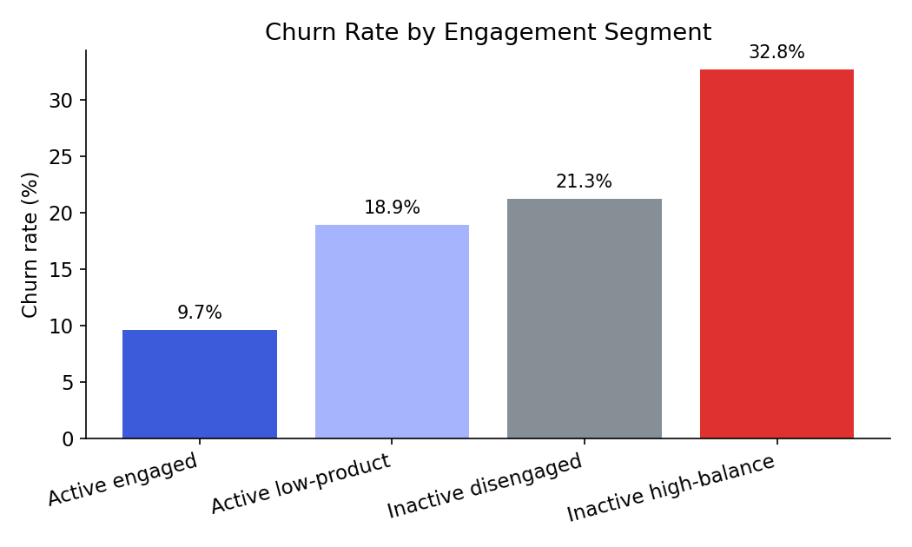
Figure 1. Churn rate by engagement segment. Wealth without engagement is the highest-risk profile.

7.2 Product Depth Has a Sweet Spot, Not a Straight Line
Product count does not reduce churn monotonically. Customers with 2 products churn at only 7.6% — the lowest of any group — but customers with 3 or 4 products churn at 82.7% and 100% respectively. This is a critical, counter-intuitive finding: cross-selling a third or fourth product is strongly associated with near-certain attrition, not loyalty. In practice this pattern typically reflects customers who took on additional products during a service or pricing problem and then left; it is a red flag to investigate, not a cross-sell target to repeat.
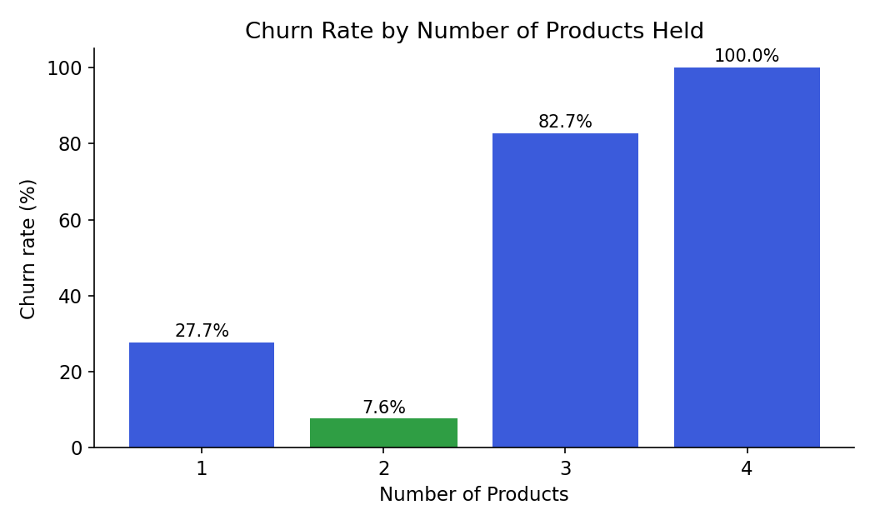
Figure 2. Churn rate by number of products held. Two products is the retention sweet spot; three or more is a warning sign.
Single-product customers churn at 27.7% versus 12.8% for multi-product customers overall — but this aggregate masks the fact that the benefit comes entirely from moving customers from 1 to 2 products, not from continued upselling beyond that point.

7.3 Balance Protects Customers Only When They Are Active
Cross-tabulating balance level against activity status shows that a high balance lowers churn only when the customer is also active. Active customers with above-median balances churn at 17.9%, while inactive customers with above-median balances churn at 32.3% — the single highest-risk combination in the dataset. Balance alone is not a retention signal; balance plus disengagement is a churn signal.
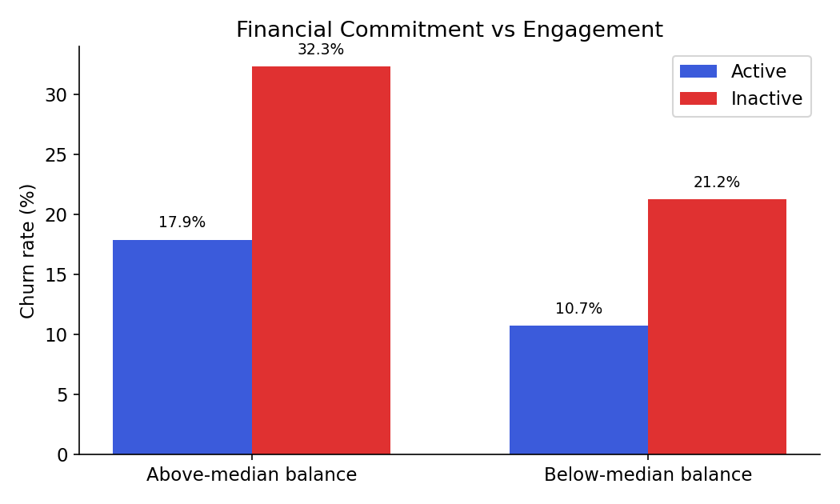
Figure 3. Churn rate by balance level and activity status. Inactive, high-balance customers are the highest-risk group.
A related risk pool: 1,247 customers (12.5% of the base) hold balances in the top quartile and are inactive. This group churns at 30.5%, representing the bank's most valuable at-risk population — large deposits, minimal engagement.

7.4 Geography and Age Compound the Risk
Germany shows a churn rate of 32.4%, roughly double France (16.2%) and Spain (16.7%), despite Germany having the highest average balance (€119,730 vs €76,486 overall) — consistent with the engagement-over-wealth pattern seen elsewhere. Age also compounds risk: churn rises steadily from 7.5% among 18-30 year-olds to a peak of 56.2% among 51-60 year-olds, before falling among 60+ customers.
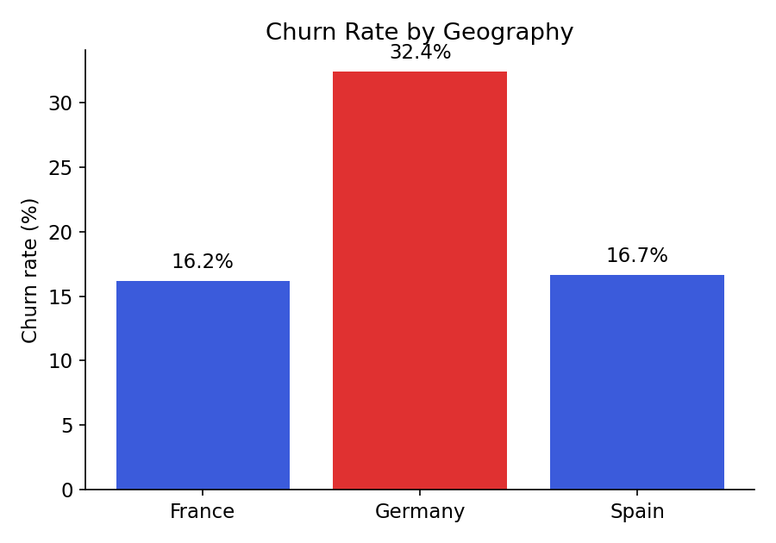
Figure 4. Churn rate by geography.
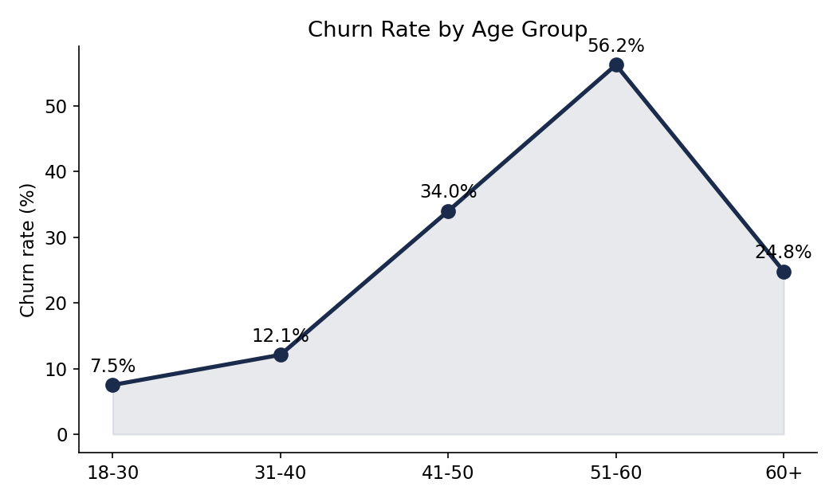
Figure 5. Churn rate by age group, peaking sharply in the 51-60 bracket.
Tenure (years with the bank) showed no meaningful relationship with churn — rates stayed within a narrow 17-23% band across all tenure lengths, indicating that loyalty is driven by current engagement and product fit, not by how long the relationship has existed.

8. Key Performance Indicators
KPI | Value | Interpretation
Engagement Retention Ratio | 1.88× | Inactive customers churn 1.88 times more often than active customers (26.9% vs 14.3%).
Product Depth Index | 2 products optimal | Churn falls from 27.7% (1 product) to a low of 7.6% (2 products), then rises sharply to 82.7-100% at 3-4 products.
High-Balance Disengagement Rate | 30.5% | Churn rate among the 1,247 customers with top-quartile balances who are inactive — the bank's highest-value at-risk pool.
Credit Card Stickiness Score | ~0.6 pt difference | Credit card ownership shows almost no retention effect (20.8% churn without a card vs 20.2% with one) — it is not a meaningful loyalty driver on its own.
Relationship Strength Index | 0.10 - 0.37 range | A composite of activity status and product depth; customers in the lowest RSI quartile churn at 36.7%, over 3.5× the rate of the top quartile (9.7%).

9. Customer Segments for Action
- "Sticky" profile (protect and replicate): Active members holding exactly 2 products — 2,446 customers, 5.6% churn. This is the target profile for cross-sell and onboarding design.
- At-risk premium (priority outreach): Inactive members in the top balance quartile — 1,247 customers, 30.5% churn. Highest financial value at risk; needs proactive relationship management, not marketing.
- Over-sold / warning flag: Customers with 3-4 products — 326 customers, 85.9% churn. Nearly all are already on their way out; the finding suggests investigating what drove them to accumulate products (forced bundling, complaint resolution offers) rather than treating this as a healthy segment.
- Germany active-monitoring: Germany customers overall, especially the 41.5% of German customers holding only 2 products who still churn at 41.4% — a market-specific dynamic worth separate investigation (competition, pricing, or service quality).

10. Recommendations
- Prioritize re-engagement over acquisition: activating a dormant customer closes roughly half the churn gap (26.9% → 14.3%) — a larger lever than most acquisition campaigns.
- Cap proactive product bundling at two products; treat any customer approaching a third product as a service-quality review, not a cross-sell win.
- Build a standing "at-risk premium" outreach queue for inactive, high-balance customers — this single segment carries disproportionate financial exposure.
- Investigate Germany specifically: its churn rate is double that of France and Spain despite higher average balances, suggesting a local, fixable driver rather than a demographic one.
- Do not rely on credit card issuance as a retention tool — the data shows negligible impact on churn.
- Track the Relationship Strength Index (activity + product depth) as a standing early-warning score, since it separates high- and low-risk customers by more than 3.5× churn.

11. Conclusion
This project reframes customer churn from a behavioral and relationship-strength perspective. By focusing on engagement and product utilization rather than demographics, it provides actionable insights for retention strategy design, product optimization, and customer loyalty enhancement. The consistent thread across every finding is the same: activity status and the right amount of product depth predict loyalty far better than income, balance, or tenure — and the bank's largest hidden risk sits precisely where balances are high and engagement is low.

